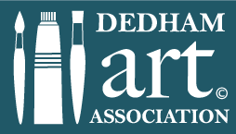 | Dedham Art Association’s Oil Demonstration  with Sam Vokey  May 14, 2024
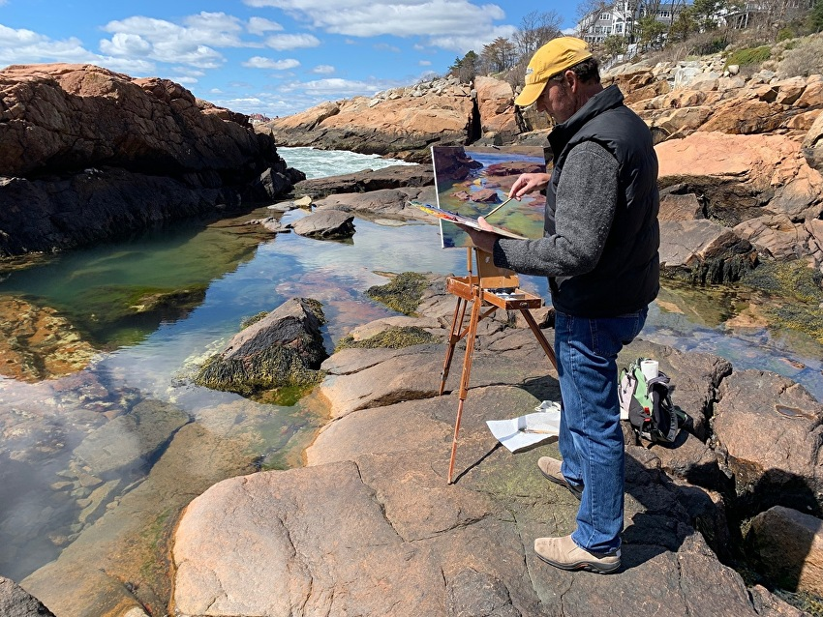
Sam Vokey is an oil painter who specializes in landscapes and commissioned custom paintings. Sam has been painting for more than 28 years. He is an elected member of The Guild of Boston Artists and has won the designation of Copley Master from the Copley Society of Boston. He is a graduate of Bowdoin College in Maine and Middlesex School in Concord.
He attended the R.H. Ives Gammell Atelier in Boston where he won a four-year scholarship. This was a European style atelier program that only admitted five students at a time. Those students worked closely with a master painter to learn the fundamentals of painting still life, landscape, portrait, and figurative work.
His painting style is most closely associated with the Boston School tradition of painting which crosses Realism with some of the softer edges and painterly qualities of Impressionism. Vokey’s landscapes and still lifes demonstrate a strong consideration for creating balance between the overall composition and the light and dark values in his paintings.
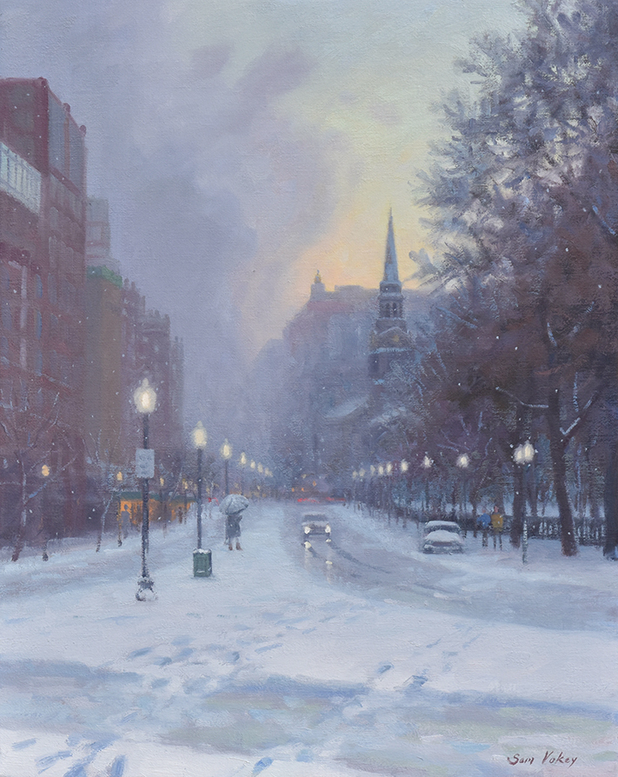
Sam has had many one-man and group shows at different galleries including most recently at The Guild Of Boston Artists 2017… a one -man show of landscapes entitled Water & Light.
Boylston Street Snow Squall
Oil on Linen, by Sam Vokey
16” x 20”

