Dedham Art Association’s Watercolor Demonstration
with Carolyn Latanision
April 9, 2024
Carolyn Latanision was fortunate to grow up in a house with a mother who was both an artist and an art teacher, so drawing and painting were simply accepted as a normal part of life. Although accomplished with oil, acrylic, pastel, and casein, watercolor became an addiction in adulthood because of the many challenges it presents. The technical difficulties made it both fun and difficult, often a gamble, the results rewarding.
She has been recognized for her efforts with many awards and by achieving Signature Membership in both the American Watercolor Society and the National Watercolor Society along with Signature Membership in numerous other national societies including Rocky Mountain, Hudson Valley, and Pennsylvania Watercolor Societies among others. In 2017, her painting was chosen as the top award-winning painting in the National Watercolor Society International Exhibition.
People and architecture have figured prominently in Carolyn’s work and in both cases urban scenes are frequently depicted. The strength and style of buildings and the many abstract patterns of light and dark they provide, the juxtaposition of people and architecture, and the connections they create, make a statement about the complexities of the time in which we live. Sometimes she’ll catch amusing and unexpected moments of life that suggest possibilities the viewer can interpret from his or her own perspective.
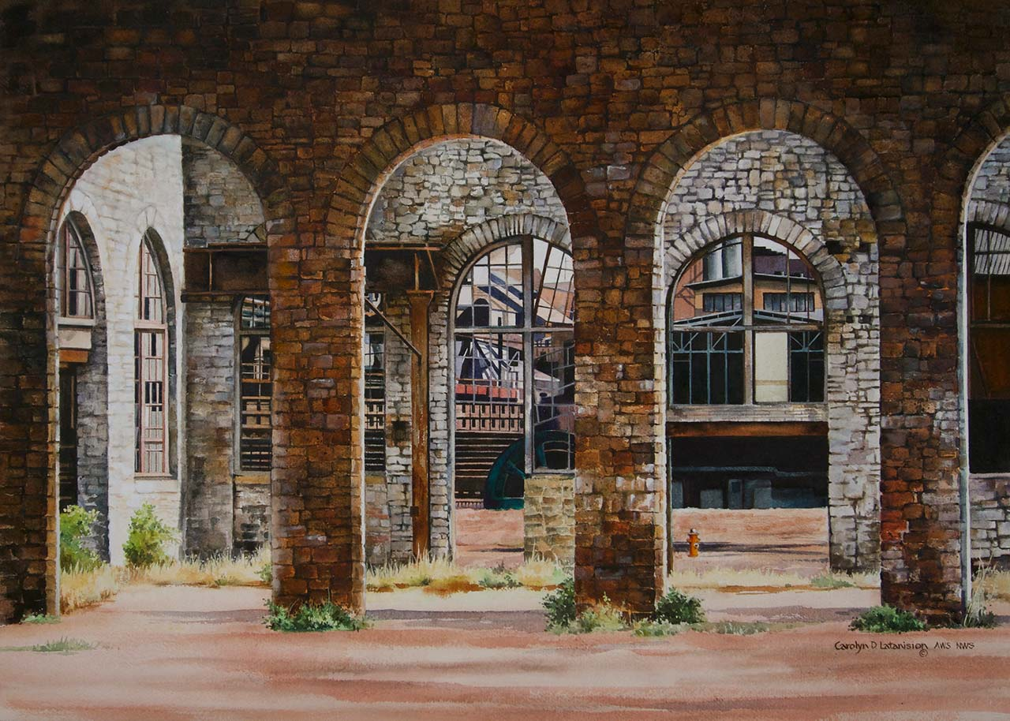
A native of Bethlehem, Pennsylvania, growing up just blocks from the blast furnaces of Bethlehem Steel Company, Carolyn was surrounded daily by the commanding structures and activities at the massive plant. When the company closed in 1995, she committed to memorializing it, knowing that it was so very important in the history of our country, and her own family, and realizing that those structures had influenced her painting and her choice of subject matter in many ways.
Carolyn has been teaching watercolor for many years and is always happy to share anything she has been able to discover.
Foundry and Furnaces
Watercolor, by Carolyn Latanision
21” x 29”

